**Krishna Bhimraj Ghorpade**

**CIN: 306603510**

**kghorpa@calstatela.edu**

**Stephens Charles Edge**

**CIN: 306637505**

**sedge@calstatela.edu**



Analysis of Global Ecological Footprint and Biological Measures in 2016

**Objective of the study**

The main goal of this project is to understand and measure ecological footprint measures variables of the ecological assets that a given population requires to produce the natural resources it consumes (including plant-based food and fiber products, livestock and fish products, timber and other forest products, space for urban infrastructure) and to absorb its waste, especially carbon emissions. The Ecological Footprint tracks the use of six categories of productive surface areas: cropland, grazing land, fishing grounds, built-up (or urban) land, forest area, and carbon demand on land. A nation’s biocapacity represents the productivity of its ecological assets, including cropland, grazing land, forest land, fishing grounds, and built-up land. [1] These areas, especially if left unharvested, can also absorb much of the waste we generate, especially our carbon emissions. Both the ecological footprint and biocapacity are expressed in global hectares — globally comparable, standardized hectares with world average productivity.

If a population’s ecological footprint exceeds the region’s biocapacity, that region runs an ecological deficit. Its demand for the goods and services that its land and seas can provide — fruits and vegetables, meat, fish, wood, cotton for clothing, and carbon dioxide absorption — exceeds what the region’s ecosystems can renew. [2] A region in ecological deficit meets demand by importing, liquidating its own ecological assets (such as overfishing), and/or emitting carbon dioxide into the atmosphere. If a region’s biocapacity exceeds its ecological footprint, it has an ecological reserve.

The Ecological Footprint adds up all the ecological services people demand that compete for space. It includes the biologically productive area (or biocapacity) needed for crops, grazing land, built-up areas, fishing grounds and forest products. It also includes the area of forest needed to absorb carbon dioxide emissions that cannot be absorbed by the ocean. Carbon from burning fossil fuels has been the dominant component of humanity’s Ecological Footprint for more than half a century and its share continues to grow. [3]

The [Ecological Footprint](https://www.thenaturalstep.de/challenge/ecological-footprint/) tells us how close we are to the goal of sustainable living. Biocapacity serves as a lens showing the capacity of the biosphere to regenerate and provide for life. It allows researchers to add up the competing human demands, which include natural resources, waste absorption, water renewal and productive areas dedicated to urban and agricultural uses.

The Global Footprint Network closely collaborates with renowned partner organizations and initiatives around the globe, among them the UN. Its national Footprint and biocapacity calculations are based on United Nations’ data sets and use between 6,000 and 15,000 data points per country and year. In addition, the calculations use some complementary data points from the current scientific literature. [4] The most recent complete set of available data covers the year 2016. The network is continually improving its methodology and data collection. As a result, the updated calculation has revealed a 16 per cent higher global carbon footprint and an 8 per cent higher global [ecological footprint](https://www.thenaturalstep.de/challenge/ecological-footprint/).

**Data set URL’s**

<https://www.kaggle.com/footprintnetwork/ecological-footprint>

<https://data.world/footprint/nfa-2016-edition>

**Data set Format**: csv

**Data Cleaning:**

**Removal of NA values present in the dataset**

**In the dataset shown below we have NA values**

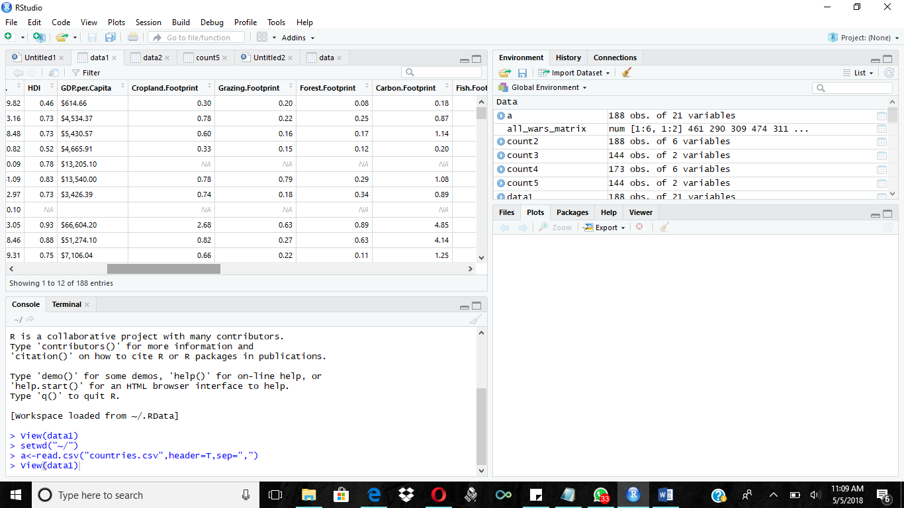

**Removed NA values**

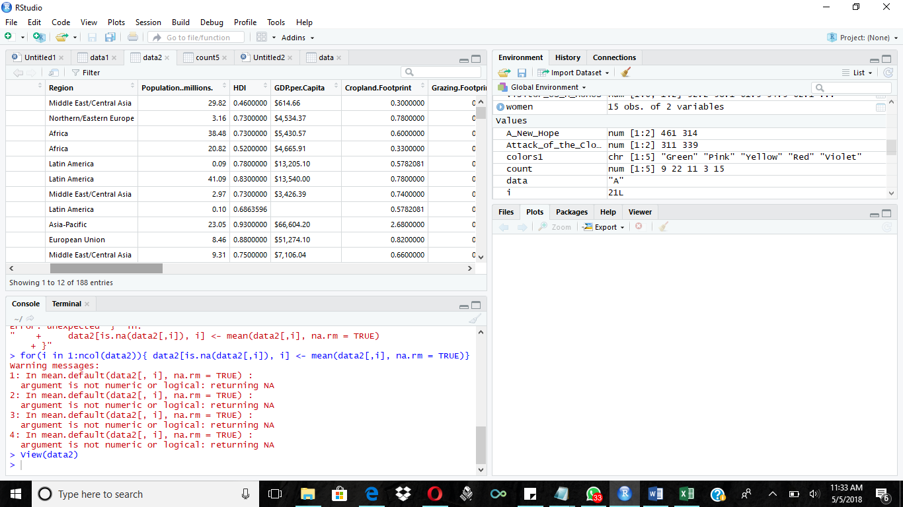

> View(data1)

> setwd("~/")

> a<-read.csv("countries.csv",header=T,sep=",")

> data1 <- read.csv("countries.csv", header=TRUE)

> View(data1)

> keepcols <- c(1,2,3,4,5,6,7,8,9,10,11,12,13,14,15,16,17,18,19,20,21)

> data2 <- data1[ ,keepcols]

> View(data2)

> for(i in 1:ncol(data2)){

+ + data2[is.na(data2[,i]), i] <- mean(data2[,i], na.rm = TRUE)

+ + }

Error: unexpected '}' in:

" + data2[is.na(data2[,i]), i] <- mean(data2[,i], na.rm = TRUE)

+ }"

> for(i in 1:ncol(data2)){ data2[is.na(data2[,i]), i] <- mean(data2[,i], na.rm = TRUE)}

Removal of unwanted columns

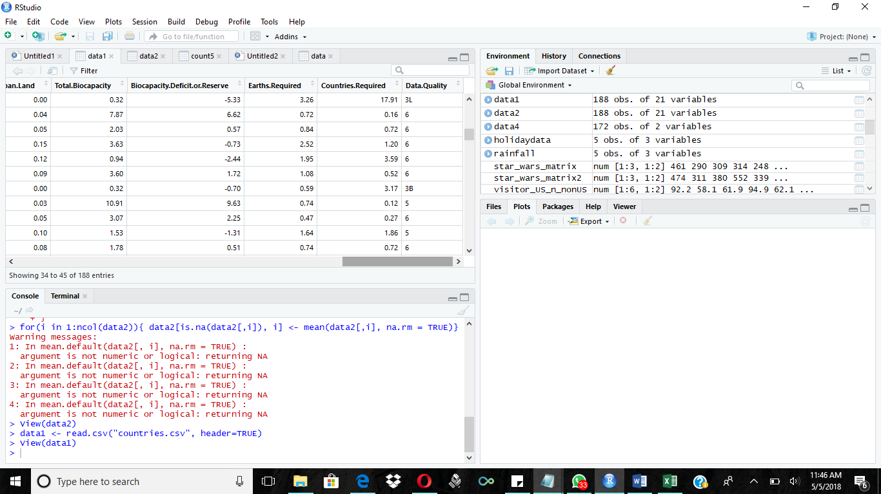

Removed unwanted columns

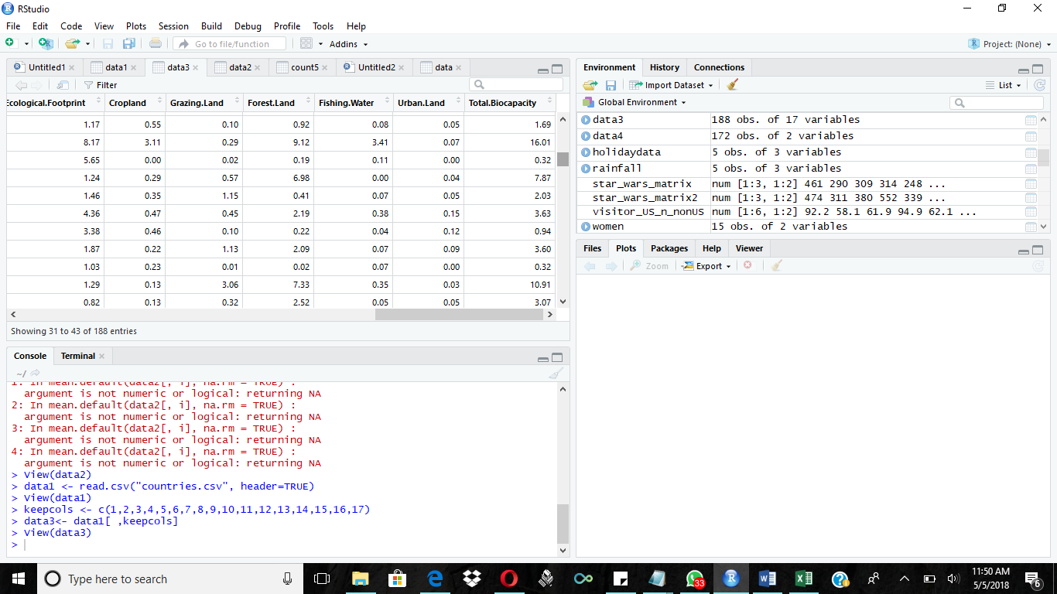

View(data2)

> data1 <- read.csv("countries.csv", header=TRUE)

> View(data1)

> keepcols <- c(1,2,3,4,5,6,7,8,9,10,11,12,13,14,15,16,17)

> data3<- data1[ ,keepcols]

> View(data3)

**Interesting Questions to Study:**

1. Compare the total ecological footprint in each country across the whole globe.(bar graph)

X axis – countries, Y axis- count of ecological footprint

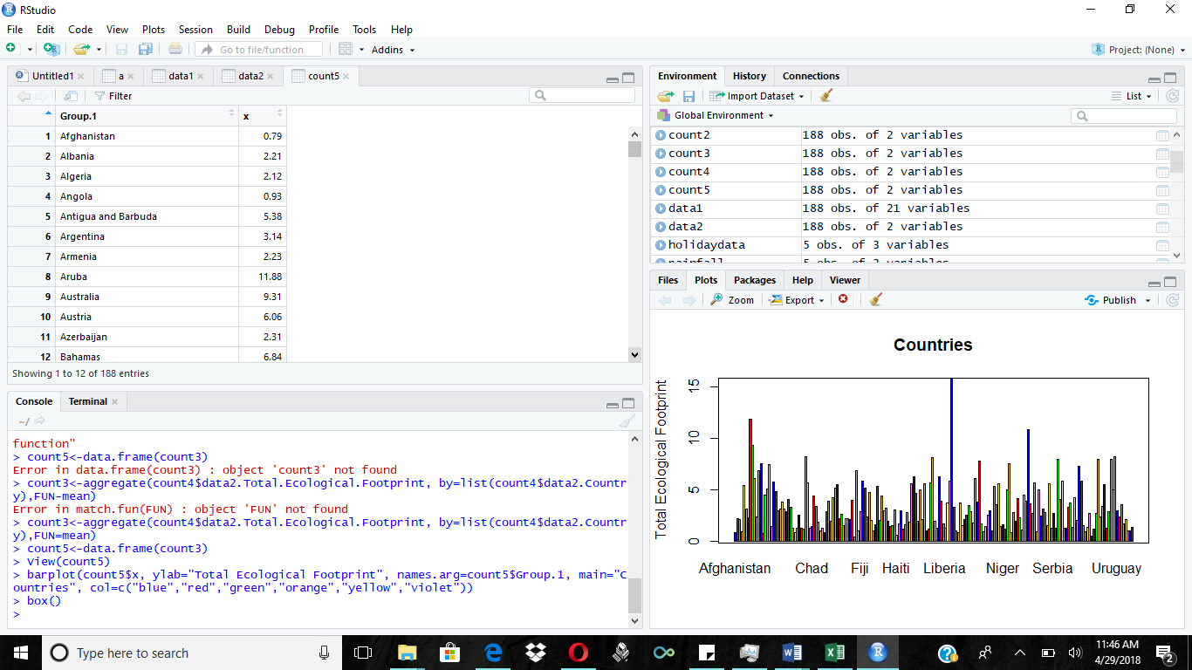



R version 3.4.4 (2018-03-15) -- "Someone to Lean On"

Copyright (C) 2018 The R Foundation for Statistical Computing

Platform: x86_64-w64-mingw32/x64 (64-bit)

R is free software and comes with ABSOLUTELY NO WARRANTY.

You are welcome to redistribute it under certain conditions.

Type 'license()' or 'licence()' for distribution details.

R is a collaborative project with many contributors.

Type 'contributors()' for more information and

'citation()' on how to cite R or R packages in publications.

Type 'demo()' for some demos, 'help()' for on-line help, or

'help.start()' for an HTML browser interface to help.

Type 'q()' to quit R.

[Workspace loaded from ~/.RData]

> setwd("~/")

> getwd

function ()

.Internal(getwd())

<bytecode: 0x00000000156387e0>

<environment: namespace:base>

> getwd()

[1] "C:/Users/Krishna/Documents"

> data1 <- countries.csv

Error: object 'countries.csv' not found

> a<-read.csv("countries.csv",header=T,sep=",")

> View (a)

> data1<-read.csv("countries.csv",header=TRUE,sep=",")

> View(data1)

> keepcols<-c(1,11)

> data2<-data1[,keepcols]

> View(data2)

> count2<-data.frame(data2$Country,data2$Total.Ecological.Footprint)

> count4<-count2[complete.cases(count2),]

> count3<-aggregate(count4$data2.Total.Ecological.Footprint, by=list(count4$data2.Country),FUN-mean)

Error in match.fun(FUN) : object 'FUN' not found

> count3<-aggregate(count4$data2.Total.Ecological.Footprint, by=list(count4$data2.Country))

Error in match.fun(FUN) : argument "FUN" is missing, with no default

> count3<-aggregate(count4$data2.Total.Ecological.Footprint, by=list(count4$data2.Country)

+

+ function(mean)

Error: unexpected 'function' in:

"

function"

> count5<-data.frame(count3)

Error in data.frame(count3) : object 'count3' not found

> count3<-aggregate(count4$data2.Total.Ecological.Footprint, by=list(count4$data2.Country),FUN-mean)

Error in match.fun(FUN) : object 'FUN' not found

> count3<-aggregate(count4$data2.Total.Ecological.Footprint, by=list(count4$data2.Country),FUN=mean)

> count5<-data.frame(count3)

> View(count5)

> barplot(count5$x, ylab="Total Ecological Footprint", names.arg=count5$Group.1, main="Countries", col=c("blue","red","green","orange","yellow","violet"))

> box()

> data1 <- countries.csv

1. Which country measured the maximum total biocapacity?
2. Which country was found to be biocapacity deficit or reserve? (box/scatter plot)

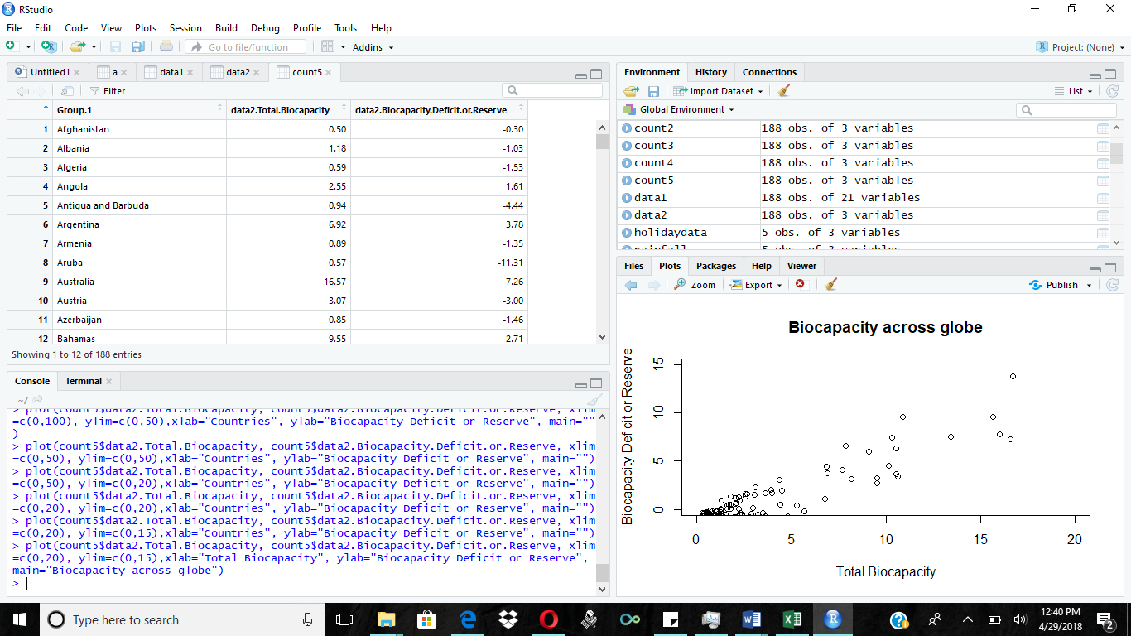



|  |
| --- |
| data1 <- countries.csv  Error: object 'countries.csv' not found  > data1<-read.csv("countries.csv",header=TRUE,sep=",")  > View(data1)  > keepcols <-c(1,18)  > data2 <-data1[,keepcols]  > count2 <- data.frame(data2$Country,data2$Biocapacity.Deficit.or.Reserve)  > count4 <- count2[complete.cases(count2),]  > count3 <-aggregate(count4[ ,2:3], list (count4$data2.Country),mean)  Error in `[.data.frame`(count4, , 2:3) : undefined columns selected  > count3 <-aggregate(count4[ ,2], list (count4$data2.Country),mean)  > count5 <-data.frame(count3)  > View(count5)  > plot(count5$data2.Country, count5$data2.Biocapacity.Deficit.or.Reserve, xlim=c(0,1000), ylim=c(0,50),xlab="Countries", ylab="Biocapacity Deficit or Reserve", main="")  > data1<-read.csv("countries.csv",header=TRUE,sep=",")  > keepcols <-c(1,17,18)  > data2 <-data1[,keepcols]  > count2 <- data.frame(data2$Country,data2$Total.Biocapacity,data2$Biocapacity.Deficit.or.Reserve)  > count4 <- count2[complete.cases(count2),]  > count3 <-aggregate(count4[ ,2:3], list (count4$data2.Country),mean)  > count5 <-data.frame(count3)  > View(count5)  > plot(count5$data2.Total.Biocapacity, count5$data2.Biocapacity.Deficit.or.Reserve, xlim=c(0,1000), ylim=c(0,50),xlab="Countries", ylab="Biocapacity Deficit or Reserve", main="")  > plot(count5$data2.Total.Biocapacity, count5$data2.Biocapacity.Deficit.or.Reserve, xlim=c(0,1000), ylim=c(0,50),xlab="Countries", ylab="Biocapacity Deficit or Reserve", main="")  > plot(count5$data2.Biocapacity.Deficit.or.Reserve,count5$data2.Total.Biocapacity, xlim=c(0,1000), ylim=c(0,50),xlab="Countries", ylab="Biocapacity Deficit or Reserve", main="")  > plot(count5$data2.Total.Biocapacity, count5$data2.Biocapacity.Deficit.or.Reserve, xlim=c(0,1000), ylim=c(0,50),xlab="Countries", ylab="Biocapacity Deficit or Reserve", main="")  > plot(count5$data2.Total.Biocapacity, count5$data2.Biocapacity.Deficit.or.Reserve, xlim=c(0,100), ylim=c(0,50),xlab="Countries", ylab="Biocapacity Deficit or Reserve", main="")  > plot(count5$data2.Total.Biocapacity, count5$data2.Biocapacity.Deficit.or.Reserve, xlim=c(0,50), ylim=c(0,50),xlab="Countries", ylab="Biocapacity Deficit or Reserve", main="")  > plot(count5$data2.Total.Biocapacity, count5$data2.Biocapacity.Deficit.or.Reserve, xlim=c(0,50), ylim=c(0,20),xlab="Countries", ylab="Biocapacity Deficit or Reserve", main="")  > plot(count5$data2.Total.Biocapacity, count5$data2.Biocapacity.Deficit.or.Reserve, xlim=c(0,20), ylim=c(0,20),xlab="Countries", ylab="Biocapacity Deficit or Reserve", main="")  > plot(count5$data2.Total.Biocapacity, count5$data2.Biocapacity.Deficit.or.Reserve, xlim=c(0,20), ylim=c(0,15),xlab="Countries", ylab="Biocapacity Deficit or Reserve", main="")  > plot(count5$data2.Total.Biocapacity, count5$data2.Biocapacity.Deficit.or.Reserve, xlim=c(0,20), ylim=c(0,15),xlab="Total Biocapacity", ylab="Biocapacity Deficit or Reserve", main="Biocapacity across globe") |
|  |
| |  | | --- | | > | |

1. Which footprint like cropland, grazing, forest etc. was found the most? (pie chart)

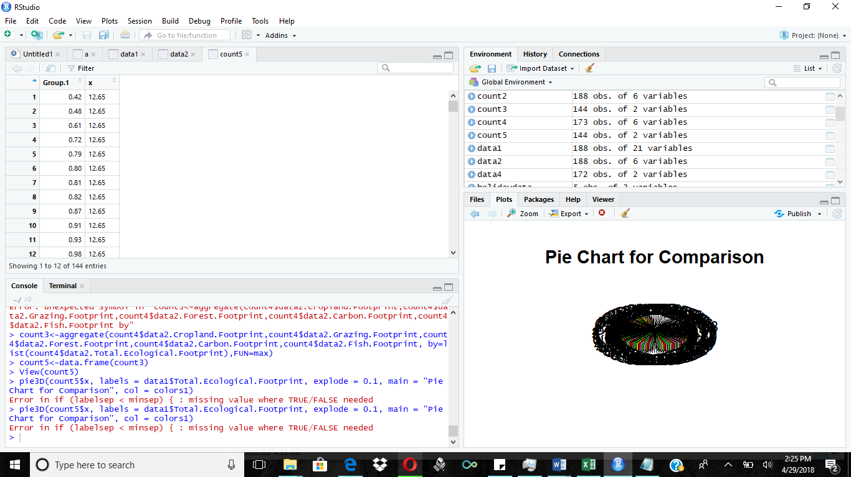



1. Which countries with Maximum Human Development Index affecting the ecological footprint? (hist)

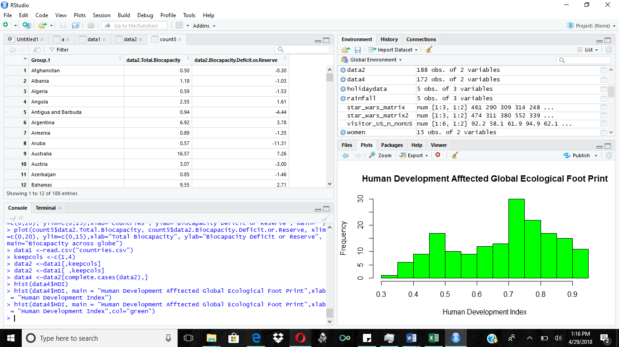



|  |
| --- |
| data1 <-read.csv("countries.csv")  > keepcols <-c(1,4)  > data2 <-data1[,keepcols]  > data2 <-data1[ ,keepcols]  > data4 <-data2[complete.cases(data2),]  > hist(data4$HDI)  > hist(data4$HDI, main = "Human Development Afftected Global Ecological Foot Print",xlab = "Human Development Index")  > hist(data4$HDI, main = "Human Development Afftected Global Ecological Foot Print",xlab = "Human Development Index",col="green") |
|  |
| |  | | --- | | > | |

Statistical function

1. Calculate Mean

data4<-read.csv("countries.csv", header = TRUE)

> low<-data4$Total.Ecological.Footprint

> mean(Total.Ecological.Footprint,na.rm=TRUE)

> mean(low,na.rm=TRUE)

[1] 3.317606

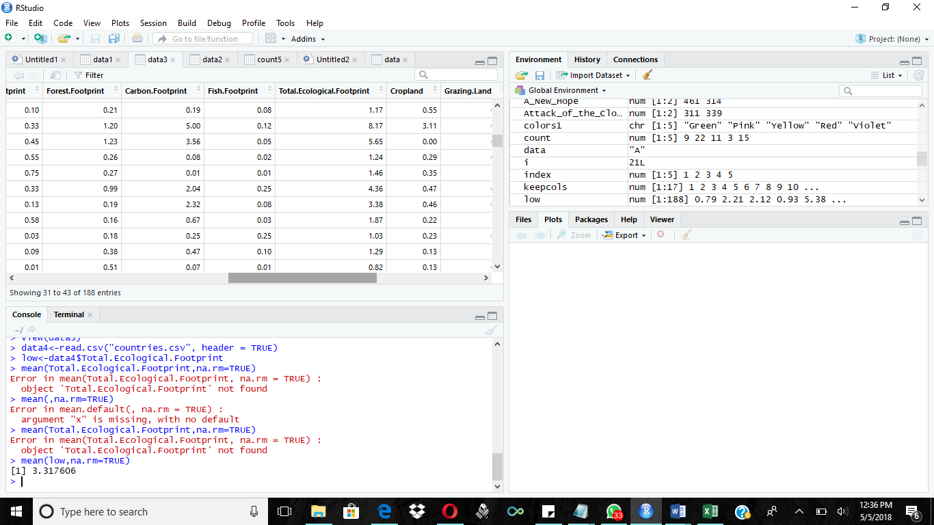

Median

|  |
| --- |
| data4<-read.csv("countries.csv", header = TRUE)  > low<-data4$Total.Ecological.Footprint  > median(Total.Ecological.Footprint,na.rm=TRUE)  Error in median(Total.Ecological.Footprint, na.rm = TRUE) :  object 'Total.Ecological.Footprint' not found  > median(low,na.rm=TRUE)  [1] 2.74 |
|  |
| |  | | --- | | > | |

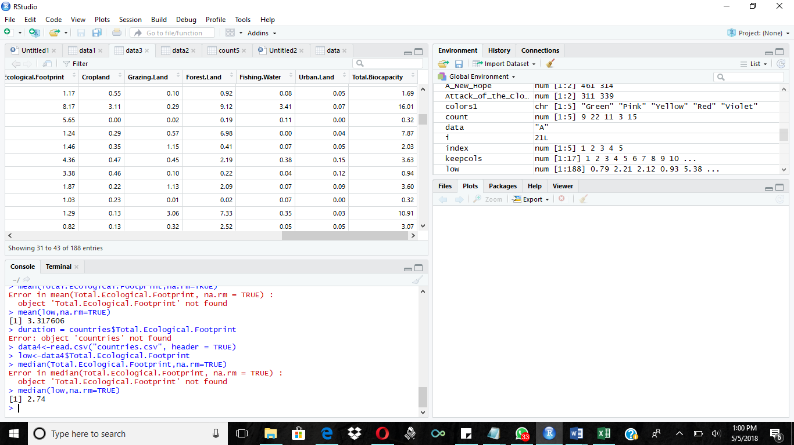

Standard Deviation

|  |
| --- |
| data4<-read.csv("countries.csv", header = TRUE)  > low<-data4$Total.Ecological.Footprint  > sd(low,na.rm=TRUE)  [1] 2.370931 |
|  |
| |  | | --- | |  | |

References:

[1] "Ecological Footprint – Footprint Network." footprintnetwork.org

Web. [http://www.footprintnetwork.org/our-work/ecological-footprint/](http://www.footprintnetwork.org/our-work/ecological-footprint/%20)

[2] "Ecological Footprint2 – About Our Earth*|* PANDA.ORG" PANDA.ORG

Web. [http://wwf.panda.org/about_our_earth/all_publications/ecological_footprint2/](http://wwf.panda.org/about_our_earth/all_publications/ecological_footprint2/%20)  .

[3] "Ecological Footprint – Challenge*|* The Natural Step" thenaturalstep.de

Web. [http://www.thenaturalstep.de/challenge/ecological-footprint/](http://www.thenaturalstep.de/challenge/ecological-footprint/%20)

[4] "Human Impact Factors – Ecological Foot Prints| Few Resources." fewresources.org

Web. [http://www.fewresources.org/ecological-footprints--human-impact-factors.html](http://www.fewresources.org/ecological-footprints--human-impact-factors.html%20)  .